**DAILY ONLINE ACTIVITIES SUMMARY**

|  |  |  |  |  |  |
| --- | --- | --- | --- | --- | --- |
| **Date:** | **30 June 2020** | **Name:** | | **KHATHEEJA SAFREENA.** | |
| **Sem & Sec** | **4th sem, 2nd year** | **USN:** | | **4al18cs037** | |
| **Online Test Summary** | | | | | |
| **Subject** | **---------** | | | | |
| **Max. Marks** | **----** | | **Score** | **---** | |
| **Certification Course Summary** | | | | | |
| **Course** | **FUNDAMENTALS OF DIGITAL MARKETING.** | | | | |
| **Certificate Provider** | **Google digital garage.** | | **Duration** | | **40 hours** |
| **Coding Challenges** | | | | | |
| **Problem Statement:3 program** | | | | | |
| **Status: Executed** | | | | | |
| **Uploaded the report in Github** | | | **Yes** | | |
| **If yes Repository name** | | | [http://shafreenasharief / lockdown-coding](http://shafreenasharief / lockdown-coding" \o "http://shafreenasharief / lockdown-coding) | | |
| **Uploaded the report in slack** | | | **Yes** | | |

Certification Course Details: (Attach the snapshot and briefly write the report for the same)

Coding Challenges Details: (Attach the snapshot and briefly write the report for the same)

**CERTIFICATION COURSE SUMMARY:**

Today I started new course **FUNDAMENTALS DIGITAL MARKETING** through **GOOGLE DIGITAL GARAGE** the course is secluded for 6hrs. After the completion of course, certificate will be provided. I completed all the module .I attempted quiz ,which gave me a clear veiw about the topics that were thought and discussed.It consists of 7 modules which also include assessments.



**CODING CHALLENGES DETAILS:**

Today I solved 3 coding challenge,

**1.Write a C Program to check whether the number is Ugly or not.**

Ugly numbers are those number whose prime factors are 2, 3 or 5. From 1 to 15, there are 11 ugly numbers 1, 2, 3, 4, 5, 6, 8, 9, 10, 12, 15. The numbers 7, 11, 13 are not ugly because they are prime. The number 14 is not ugly because in its prime factor the 7 will come.

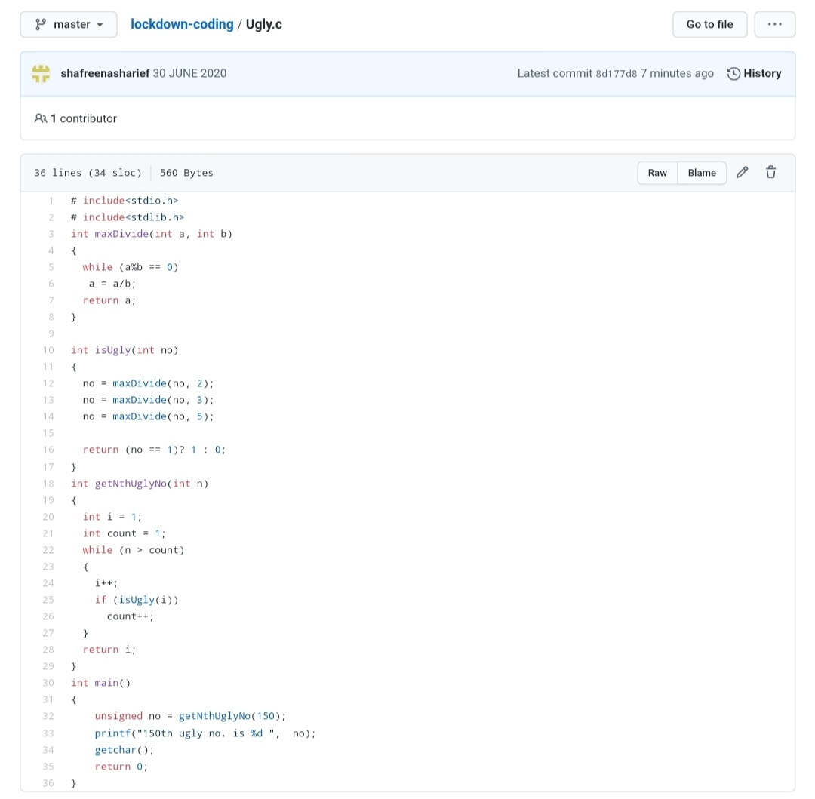

**2.** **Write a C Program to generate first n Ugly Numbers**

Ugly numbers are those number whose prime factors are 2, 3 or 5. From 1 to 15, there are 11 ugly numbers 1, 2, 3, 4, 5, 6, 8, 9, 10, 12, 15. The numbers 7, 11, 13 are not ugly because they are prime. The number 14 is not ugly because in its prime factor the 7 will come.

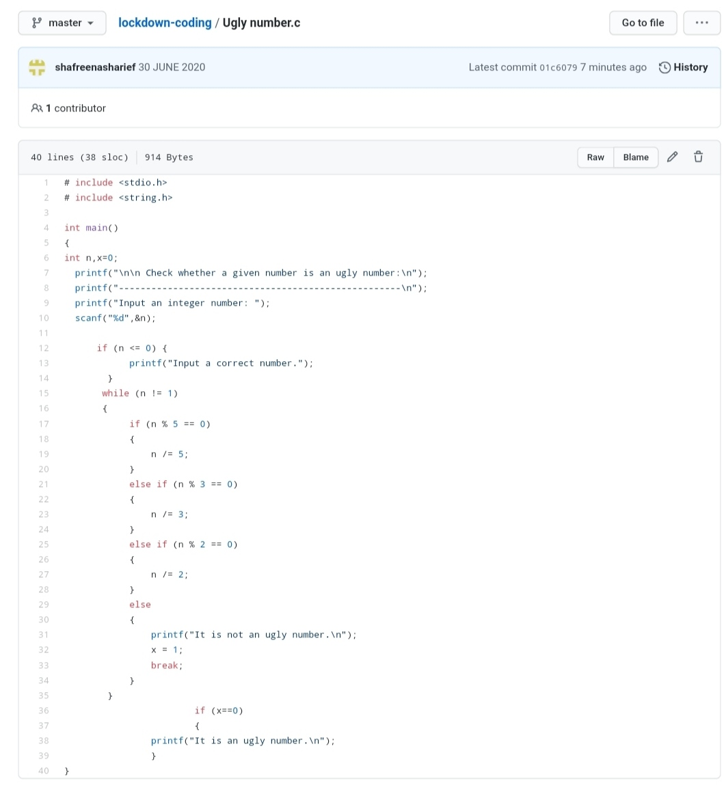

**3.** **Write a C++ Program to Move all zeroes to end of array using Two-Pointers**

Given an array of random numbers, Push all the zero’s of the given array to the end of the array. For example, if the given arrays is {1, 0, 2, 6, 0, 4}, it should be changed to {1, 2, 6, 4, 0, 0}. The order of all other elements should be the same.

Examples:

Input: arr[]={8, 9, 0, 1, 2, 0, 3}  
Output: arr[]={8, 9, 1, 2, 3, 0, 0}  
Explanation:  
Swap {0 ,1} -> Resulting array {8, 9, 1, 0, 2, 0, 3}  
Swap {0 ,2} -> Resulting array {8, 9, 1, 2, 0, 0, 3}  
Swap {0 ,3} -> Final array {8, 9, 1, 2, 3, 0, 0}

Input: arr[]={4, 5, 0, 0, 0, 0, 6, 7}  
Output: arr[]={4, 5, 6, 7, 0, 0, 0, 0}

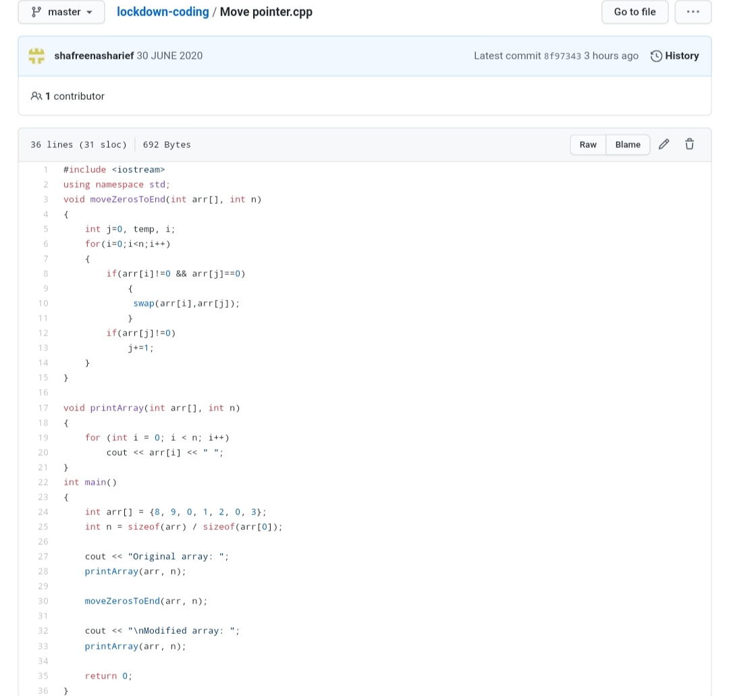

***EXTRA ACTIVITY :***

Today I attended Online training on C++ from 12:00-2:00 PM.

Quizzes are conducted at the end of the class.

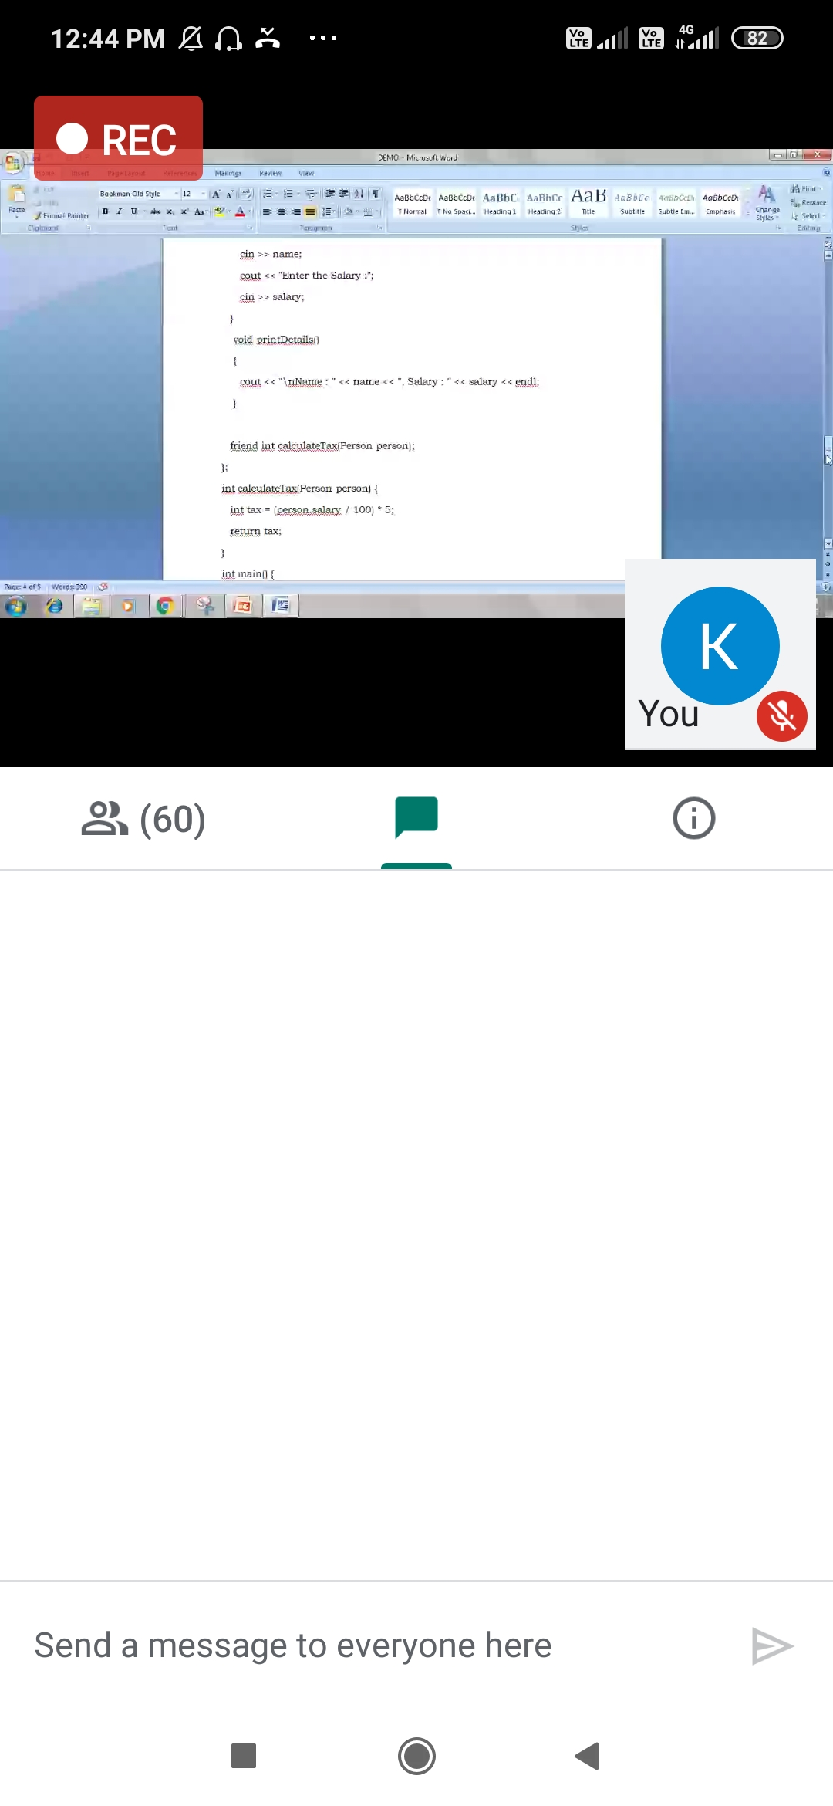

SOLUTION : I have uploaded the solution of the above 1 coding problems in my GitHub repository.

[http://shafreenasharief / lockdown-coding](http://shafreenasharief / lockdown-coding" \o "http://shafreenasharief / lockdown-coding)

[http://shafreenasharief / locked-down--certification-course](http://shafreenasharief / locked-down--certification-course" \o "http://shafreenasharief / locked-down--certification-course)

[http://shafreenasharief / Daily\_Report](http://shafreenasharief / Daily_Report" \o "http://shafreenasharief / Daily_Report)